template, guidelines and style stipulations for the final layout of the text to be collected in the proceedings of inter≈ architecture and photography conference (arial 16pts, all lower case, 1 line spacing, left alignment)
Name 1 Surname 1 (Profession / University, Department, e-mail), Name 2 Surname 2 (Profession / University, Department, e-mail), etc. (Arial 9pts, left alignment, 1’15 line spacing)
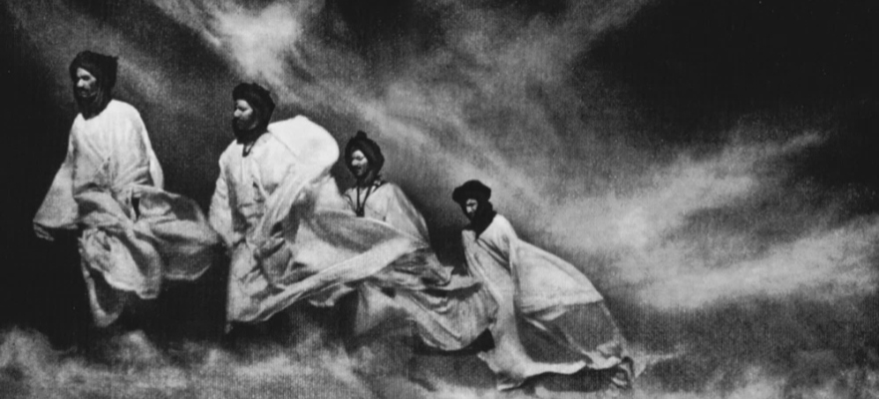
Between the title of the article and the abstract, a photograph must be included footnoted by the corresponding caption. Both the caption and the image must be inserted into a table without borders with a single column and two rows: the image will be placed on the top row and a brief description (if any) at the bottom, as well as the author, title and other possible image’s data. I.e: Jose Ortiz Echague, Scirocco, North Africa, 1915 (Author, Title of the photograph, place where it was taken, year). This table will present 0.1cm upper and lower margins, the text should follow justified alignment.

keywords: template, instructions, style, conference (9pts arial, bold, left alignment)

ABSTRACT: The title will be followed by a brief summary of the text whose length should not exceed 300 words. In any case, the first page of the article should include just the title, the cover image, the keywords and the abstract. Therefore, the body of the article begins on the next page. It is recommended to use a direct language, placing the emphasis on main and original contributions and avoiding repetitions of fragments used throughout the text. (Arial, 11pts, previous spacing 6pts, later spacing 8pts, 1'15 line spacing, justified alignment).
The title will be followed by a brief summary of the text whose length should not exceed 300 words. In any case, the first page of the article should include just the title, the cover image, the keywords and the abstract. Therefore, the body of the article begins on the next page. It is recommended to use a direct language, placing the emphasis on main and original contributions and avoiding repetitions of fragments used throughout the text. (Arial, 9pts, previous spacing 6pts, later spacing 8pts, 1'15 line spacing, justified alignment).
a. sections (arial 14pts, all lower case, left alignment, numbering a, b, c, etc.)
This document is at the same time an example, the guidelines and a template of the appropriate format the texts must follow to be included in the proceedings of the international conference inter≈ architecture and photography that will take place in Pamplona between the 2nd and the 4th of November of 2016. Articles should be typed on A4 size (210x297mm), vertically, with margins 2.5cm upper and lower, and 3cm right and left. . (Arial, 10pts, previous spacing 0pts, later spacing 8pts, 1'15 line spacing, justified alignment). The first page must include the paper title, identification of all authors, a cover photograph with its corresponding caption, the keywords and a summary in the language of the article. In the following pages it will be placed the body of the article, ordered (or not) in different sections, and all the information, including pictures, tables, images, etc. At the end of the article, it should also be included another table with the bibliography referenced throughout the text.
To facilitate the work to the author, this sheet contains a palette of styles (Word) designed specifically for the conference texts and are as follows: 1 Title INTER, 2 Authors INTER, 3 Caption INTER, 4 INTER Keywords, 5 Summary INTER, 6 Section INTER, 7 Text INTER 8 Subsection INTER. Although the use of these styles should be sufficient to accomplish the style rules that are requested by this document, we have tried to record in every part of this template the requirements and specifications of font, formatting, paragraph, line spacing and other data. The only font used is Arial. You can freely structure, with the number of sections you want, or without sections. Subsections may also be included, as follows below.
subsections (arial 12pt, all lower case, left alignment, without numbering)
The style for a subsection text is the same as the one used on the rest of the article (9pts Arial, justified alignment, 1'15 line spacing, previous spaced 0, later spaced 8pts).
As in the rest of the communication, the alignment must be justified. It is not necessary to number these subsections. To separate sections a paragraph ("enter") shall be inserted.

b. quotes
The quotes must follow the same style as the text, they must bear quotation marked, and must incorporate, always, the correspondent note, which will be added at the end of the text: "This is an example of how a quotation should be included".
The note shall include all the details of the source, according to the stipulations of bibliographic style contained in the 16th edition of the Chicago Manual of Style and are available at http://www.chicagomanualofstyle.org/. Some frequent examples are included at the end of this template.
To move the references to the end of the text (Word), REFERENCES / FOOTNOTES / POSITION: endnotes.

c. sending text and electronic form
Works must necessarily meet the specifications herein. Sending texts, in DOCX and PDF format, must be done through the computer platform based on the Open Journal System standard which can be accessed through the conference website.

d. Figures: pictures, tables, images, etc.
You must include only those considered essential for the understanding of the article, and the number of images shouldn’t exceed 7 (excluding the photograph of the first page). The quality of these figures (photographs, drawings, maps, charts, diagrams, etc.) must have a minimum quality of 300 dpi. For pictures in horizontal format, whenever possible width will be adjusted to the margins of the page, i.e. 237mm. For vertical formats, the size of the photo is a personal choice of the author, although they must be center aligned (to do this, align the table to the center, as it is done in the example below):

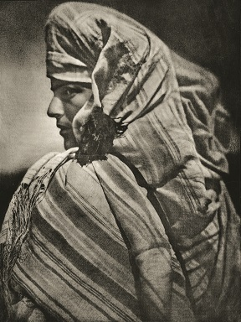
Fig. 1. This is an example that illustrates how to insert a picture in vertical format. José Ortiz Echagüe, Retrato, North of Africa, 1915.

All the images must be inserted into a table compounded by two rows and one column, as it was explained on the first page. In the case of vertical images, the image width should be the desired one and aligned to the center of the page. The text of the article will resume after "Enter" apart. The upper and lower margins of the cells in this table will be 0.1cm. In the cell dedicated to the caption, it will express the number of the corresponding figure (Fig. #) First. The text will be justified alignment and the style should be "Caption INTER".
origin of images and permissions
After the description and the figure data (author, title, place, year) it must be always referenced its origin. If the source is a publication, you must follow the stipulations for references.
Furthermore, the author is responsible for obtaining the permission for the publication of the images if required, and must submit along with the article through the computer platform OJS. All images must be submitted as individual archives through the computer platform OJS.

e. extension
Full extension of the article should be between 3,000 and 4,000 words, including all sections but the cv (title, subtitle, authors, abstract, captions, endnotes, sections, subsections, bibliography, etc.) Content in this limit is set another one of 300 words for the abstract and another of 1,000 words for the endnotes and the bibliography.

f. bibliography
At the end of the article a list of bibliographical sources used in alphabetical order by author, as follows, must be included:
Choi, Mihwa. “Contesting Imaginaries in Death Rituals during the Northern Song Dynasty.” PhD diss., University of Chicago, 2008.
Kelly, John D. “Seeing Red: Mao Fetishism, Pax Americana, and the Moral Economy of War.” In Anthropology and Global Counterinsurgency, edited by John D. Kelly, Beatrice Jauregui, Sean T. Mitchell, and Jeremy Walton, 67–83. Chicago: University of Chicago Press, 2010
Pollan, Michael. The Omnivore’s Dilemma: A Natural History of Four Meals. New York: Penguin, 2006.
Ward, Geoffrey C., and Ken Burns. The War: An Intimate History, 1941–1945. New York: Knopf, 2007.
Weinstein, Joshua I. “The Market in Plato’s Republic.” Classical Philology 104 (2009): 439–58.

g. cv
Name 1 Surname 1
Finally, it includes a brief resume of a paragraph (no more than 150 words) by each author of the communication.
Name 2 Surname 2

For references, NO DEFAULT STYLE IS REQUIRED: arial, 8 pts, justified alignment, line spacing 1 line. Below are listed some common examples; for further information you can access the Chicago Manual of Style website. A BOOK (ONE AUTHOR): 1. Michael Pollan, The Omnivore’s Dilemma: A Natural History of Four Meals (New York: Penguin, 2006), 99–100. 2. Pollan, Omnivore’s Dilemma, 3. Bibliography: Pollan, Michael. The Omnivore’s Dilemma: A Natural History of Four Meals. New York: Penguin, 2006. B BOOK (TWO OR MORE AUTHORS) 1. Geoffrey C. Ward and Ken Burns, The War: An Intimate History, 1941–1945 (New York: Knopf, 2007), 52. 2. Ward and Burns, War, 59–61. Bibliography: Ward, Geoffrey C., and Ken Burns. The War: An Intimate History, 1941–1945. New York: Knopf, 2007. C BOOK CHAPTER 1. John D. Kelly, “Seeing Red: Mao Fetishism, Pax Americana, and the Moral Economy of War,” in Anthropology and Global Counterinsurgency, ed. John D. Kelly et al. (Chicago: University of Chicago Press, 2010), 77. 2. Kelly, “Seeing Red,” 81–82. Bibliography: Kelly, John D. “Seeing Red: Mao Fetishism, Pax Americana, and the Moral Economy of War.” In Anthropology and Global Counterinsurgency, edited by John D. Kelly, Beatrice Jauregui, Sean T. Mitchell, and Jeremy Walton, 67–83. Chicago: University of Chicago Press, 2010. D JOURNAL ARTICLE 1. Joshua I. Weinstein, “The Market in Plato’s Republic,” Classical Philology 104 (2009): 440. 2. Weinstein, “Plato’s Republic,” 452–53. Bibliography: Weinstein, Joshua I. “The Market in Plato’s Republic.” Classical Philology 104 (2009): 439–58. E DISSERTATION 1. Mihwa Choi, “Contesting Imaginaires in Death Rituals during the Northern Song Dynasty” (PhD diss., University of Chicago, 2008). 2. Choi, “Contesting Imaginaires.” Bibliography: Choi, Mihwa. “Contesting Imaginaires in Death Rituals during the Northern Song Dynasty.” PhD diss., University of Chicago, 2008.

